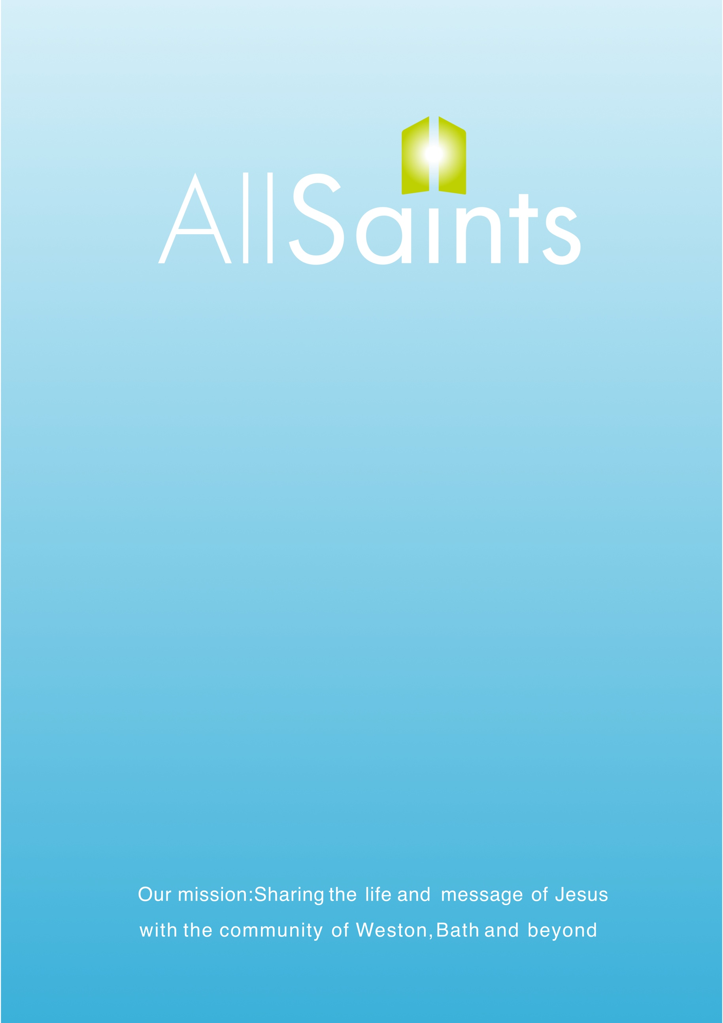

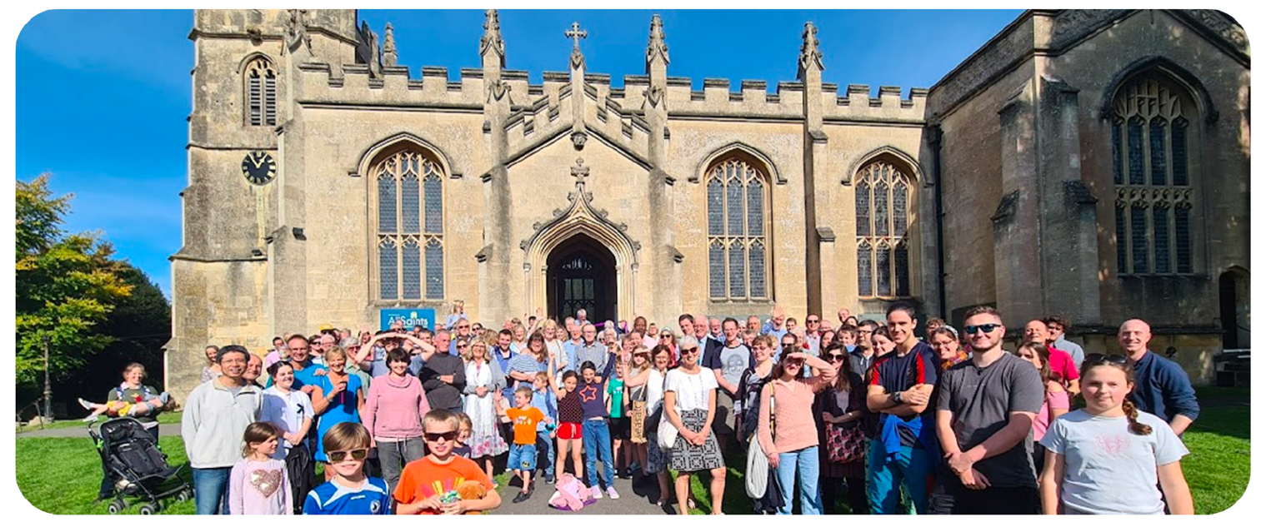

All Saints Church, Weston, Bath

Church Administrator
Job Information Pack
May 2026

Thank you for your interest in this position at All Saints, we are praying for the right person to come and join the team

The following information pack should give you a comprehensive idea of what we are looking for and what opportunities there are as an employee of the church. If you have any specific further queries, please do call for an informal chat.

POSITION SUMMARY

We have an exciting opportunity to now appoint a Church Administrator to be a core part of our team that oversees the smooth running of all aspects of our church life. We are seeking a confident, personable, and thoughtful individual with the drive, commitment, and attention to detail necessary to handle the day to day challenges of a busy office environment.

The Church Administrator will be a faithful team player who is articulate, good with people, tidy, patient, but a completer-finisher. Must be able to use Microsoft Word, Excel and PowerPoint, and be efficient at answering emails sensitively. Experience of graphic design software such as Canva or Photoshop would be an advantage. Experience of Churchsuite or equivalent CRM (Customer Relationship Management) would be an advantage. A Christian who manages their time and priorities prayerfully and carefully.

This is a part-time permanent role at 22.5 hours per week and we will require those hours to be worked across three or four days of the week with some flexibility available. Core hours will be: Tuesday mornings, Thursdays and Fridays. The remaining time can be worked flexibly. There will be occasional work required on Saturdays and Sundays.

The Church Administrator will work closely with the Rector and Head of Operations to support the PCC in maintaining its administrative responsibilities. They will also interact with other staff regularly, including the Clergy, Community Facilities Manager, Finance Officer and other ministry staff. They will manage the daily administrative tasks as set out in the role description below as well as assisting with one-off events and activities as they occur.

Working for the church in a Christian context, it is expected that the Church Administrator will be: of good character with a servant hearted working style; committed to church and community feeling like family; committed to supporting the ministry staff team who are seeking to grow the church through evangelism. You would be expected to attend office prayers on occasions if this coincides with your working hours.

We take our responsibility for the safeguarding of children and adults seriously. Our recruitment and training processes reflect this commitment.

PARISH PROFILE

All Saints is a thriving Church of England church based in Weston on the outskirts of Bath, with a core mission of sharing the life and message of Jesus.
We have three services every Sunday, midweek services, special events and over 250 members. We are excited to be in a growing season of ministry following the extensive refurbishment of our main church building and looking forward to further growth with many more people becoming Christians and newcomers joining the church.

Weston is a community of around 10,000 people in the suburbs of Bath with a large hospital, two primary schools and a secondary school within the parish. All Saints is made up of people of all ages including lots of children, young people and younger adults but there is huge potential for growth in all areas and a commitment to see Jesus honoured in every generation.

Our core values underpin our mission and guide our staff appointments – we believe that Church is family, rooted in God’s Word, empowered by His Spirit, making Disciples of Jesus through both words and actions. We are also committed to our safeguarding and safer recruitment policies, ensuring that we are protecting children, young people and adults.

The Employer – PCC of All Saints Weston, Bath.

THE PARISH OF ALL SAINTS WESTON
WITH ST MARY’S LANGRIDGE AND ST MARTIN’S NORTH STOKE

Electoral Roll: 227 for 2025
Church Members approximately 320

Current All Saints Ministry Staff: Rector: Tom Yacomeni
Churchwarden: Rosie Coates
Churchwarden: Peter Ward
Curates: Emma King, (Claire Morrish, from 28 June)
Trainee Youth Leader: Theo Holden
Children’s and Families leader: Jo Tucker
Worship Leader: Andrew Kitcatt
Lay Reader: Tom Peryer
Seniors Pastor and Lay Reader: Pippa Page
Life Events Coordinator: Mercia Braybrooke

Current Facilities Staff Team: Head of Operations: Gary Oaten
Facilities Manager: Ellie Kingston
Finance Officer: Lisa Vernalls
Church Administrator (To be appointed)
Facilities Assistant: Jacob Walsh
Caretakers: Simon Briffett
Church Caretaker: Dominic James
Cleaner: Peter Room

Buildings:
All Saints Church are responsible for five buildings in Weston currently: All Saints Church, All Saints Centre, Weston Hub, The former Infants school on the High Street and 19 Chandler Close (A residential property that is let).

All Saints Centre, refurbished in 2001, provides a place for many church and community groups as well as commercial and private lets such as wedding receptions. It is also the base for our offices: Church Office, Centre Office, Curate’s Office and Children’s and Families Worker Office.

All Saints Church dates from the medieval period but was substantially rebuilt by the early Victorian era. The completion of our refurbishment project in 2024 now brings the church building firmly into the 21st Century with much improved facilities and more flexibility with regard to its use.

Weston Hub is a council owned building and All Saints took control of the building at the start of 2018 and have built it into a busy and vibrant all age community centre. All Saints Welcome Café and Food Club runs out of this building weekly on Mondays.

The former infants school needs major refurbishment work and its future use in the community is currently being debated by the PCC.

19 Chandler Close, is a modernish end of terrace house.

ROLE DESCRIPTION

Operational

Enquiry Handling and Contact Management
- Manage the day to day office enquiries received in person, by phone and email.
- Manage the Address Book, Teams/Rotas and Small Groups sections of our ChurchSuite database.
- Manage Newcomers’ data collection
- Assist other staff and volunteers with Rotas, Teams and Groups data on ChurchSuite

Safeguarding Administration
- Complete your own safeguarding training as required
- Manage the DBS checking procedure for staff and volunteers
- Handle Training Reminders
- Ensure the Parish Dashboard online tool is updated to reflect DBS certificates and completed safeguarding training
- Organise First Aid Training for Staff and volunteers as required
- Ensure members address book records in ChurchSuite are updated to reflect training completed.

Communications
- Produce the Church News Sheet on a weekly basis (email and printed versions)
- Manage the church welcome desk information and display boards
- Handling the office printing requirements
- Willingness to be contacted out of hours if necessary

Ministers Assistance
- Printing materials: Orders of service, Sermon series term cards, Study notes and booklets, Event Flyers
- Church suite rotas assistance
- Purchasing of communion wine and wafers, Candles, baptism certificates and festival supplies.
- Church Events Support Registrations and sign ups

Compliance Assistance and Church Warden Assistance
- Compile Trustees Annual Report
- Statistical returns
- Church Terrier, Inventory
- Storage of historical documents and valuables
- Assist Electoral roll officer with data collection
General Administration
- Assist with grant applications
- Carry out and promote recycling and other sustainable practices.

PERSON SPECIFICATION

- A committed Christian – the role includes the need to relate the Christian faith, in a variety of contexts, to people both in and outside of the church, with a willingness to pray for the work. (this is a Genuine Occupational Requirement)

- Self-starter with a can-do attitude.
- Personal and friendly individual who can communicate very well.
- Ability and willingness to see tasks through to completion
- Very at home using a computer with Microsoft applications.
- Intelligent and able to pick things up quickly and efficiently.
- Good sense of humour and sense of fun that reflects in the work.
- Good team player who likes to interact.

EXPERIENCE
- Experience of working in a church context would be desirable
- A good standard of English and maths is required in order to work quickly and efficiently with tasks.
- Great computer skills - A very good working knowledge and experience with using Microsoft Office, Word, Excel and Powerpoint. A quick learner for our bespoke software tools: ChurchSuite for bookings, calendar, address book etc and QuickBooks for invoicing. Training will be provided ,of course.
- Good with words and an eye for graphics and layouts is desired.
- Used to dealing with people in person and on the phone with a pleasant, caring and ‘can do’ attitude.

SKILLS
- Excellent verbal, written and interpersonal communication skills
- Strong organisational and administrative skills
- Able to see the bigger picture whilst maintaining grip on detail
- A self-starter able to work on own initiative, to identify problems and find solutions quickly
- Able to prioritise competing demands
- Ability to work efficiently under pressure, exercising initiative and judgement
- Ability to respond to changing needs within the daily, weekly and annual schedule
- Willingness to work flexibly

KNOWLEDGE
- Good level of secondary education
- Further education qualifications (desirable)
- Understand Safeguarding procedures and be willing to undertake training
- Possess an up to date ‘Enhanced’ DBS
- Knowledge and experience of Microsoft office products essential and ChurchSuite or other CRM skills is desirable.
BENEFITS

- Wide variety of tasks within the role, meaning every day is different.
- Great team to work with in a Christian environment.
- Five weeks holiday plus bank holidays.
- Pension scheme with employers contribution.
- Some Flexi-time available.
- Advancement in role with in house training from experienced staff.
- Contribution towards mobile phone costs.
- Plenty of opportunity to take part in church services and events, both locally and nationally.
A DBS check will be required to be completed before starting and two online safeguarding training modules will also be required to be completed prior to the job start date. All Saints will pay the successful candidate for the time taken to do this training prior to starting the job and that will be paid as overtime in the first main salary payment.

TERMS AND CONDITIONS OF WORK

Contract: | This is a permanent part-time contract. It will include a full probationary review after 6 months. Ideally employment will commence on Wednesday 1st July 2026.  It is desirable that the candidate would attend All Saints Church and makes this their home church. Applicants must be eligible to work in the UK.
Hours of work:  Overtime:  Place of work: | 22.5 hours per week. There is some flexibility on start/finish times, and your hours could be arranged child care needs etc. General office hours usually from 9.00am to 5.00pm with half an hour for lunch. There will be some occasional working requirements on Saturdays and Sundays.  Overtime is not normally available as part of this post, but on a few occasions, such as large events which require additional staff out of hours, overtime payments will be offered.  Normally All Saints Centre, Weston Hub and All Saints Church, but also at any other nearby locations requested by the employer.
Salary: | £26,754 Annual FTE Salary (£17,702 pro rata for a 22.5 hour week – £15.13 per hour.)
Annual Leave: | 25 days a year plus all bank holidays (usually 8) Not to be taken in the weeks leading up to Easter and Christmas
Pension:  Notice Period: | The parameters of the ASW Auto-Enrolment Scheme are 5% gross employee contributions and 3% gross employer contributions, based upon “Qualifying Earnings”. This is an ‘opt out’ scheme and more details will be provided to the successful applicant.  Notice periods by either party are based on one month’s written notice after the probationary period and subject to compliance only with statutory dismissal and disciplinary procedures. (See also detailed explanation of the ACAS based procedure within our Employee Handbook.) However, your employment may be summarily terminated where you are found guilty of gross misconduct.

Support Structure
Your line manager for HR purposes is the Head of Operations who is there to support you fully and provide training for further development in the role. The Rector and Clergy Team will allocate some of your tasks on a day to day basis. Other staff will always assist in sharing the workload when our church is at its busiest.
Probationary period with a six month review. Annual reviews after the probationary period.
Other support is provided through our Rector, our HR Officer, the Treasurer and Churchwardens, the PCC and our Safeguarding Officers.

THE APPLICATION TIMESCALES
We will accept applications and look at them as they come in. Applications close on Friday 22nd May at 5.30pm. We will call to interview those who we think would be suitable for the job and interviews will be carried out, preferably on Tuesday 26th May, or by mutual agreement as soon as possible after that date.
At the interview there will be the opportunity for an extensive tour of our buildings and to meet other members of staff and ask questions. Refreshments will be provided.
Decisions will be made within one working day after the last candidate is called to interview and all interviewees will be informed of the outcome.

Ideally the start date for the successful candidate would be Wednesday 1st July 2026.

